## 

## START

*What do we need to* ***start doing****?*

*Is there a tool, process, or resource that would help us* ***achieve our goals****?*

*What* ***strengths*** *do we have that we aren’t currently leveraging?*

## STOP

*What do we need to* ***stop doing****?*

*Are we doing something that is* ***holding us back****?*

*What do we do that* ***takes up a lot of resources*** *but* ***doesn’t produce significant results****?*

*Is there a tool or process that* ***isn’t working*** *the way it was intended to?*

## CONTINUE

*What are we* ***doing right*** *that we need to continue doing?*

*What* ***works well*** *that shouldn’t change?*

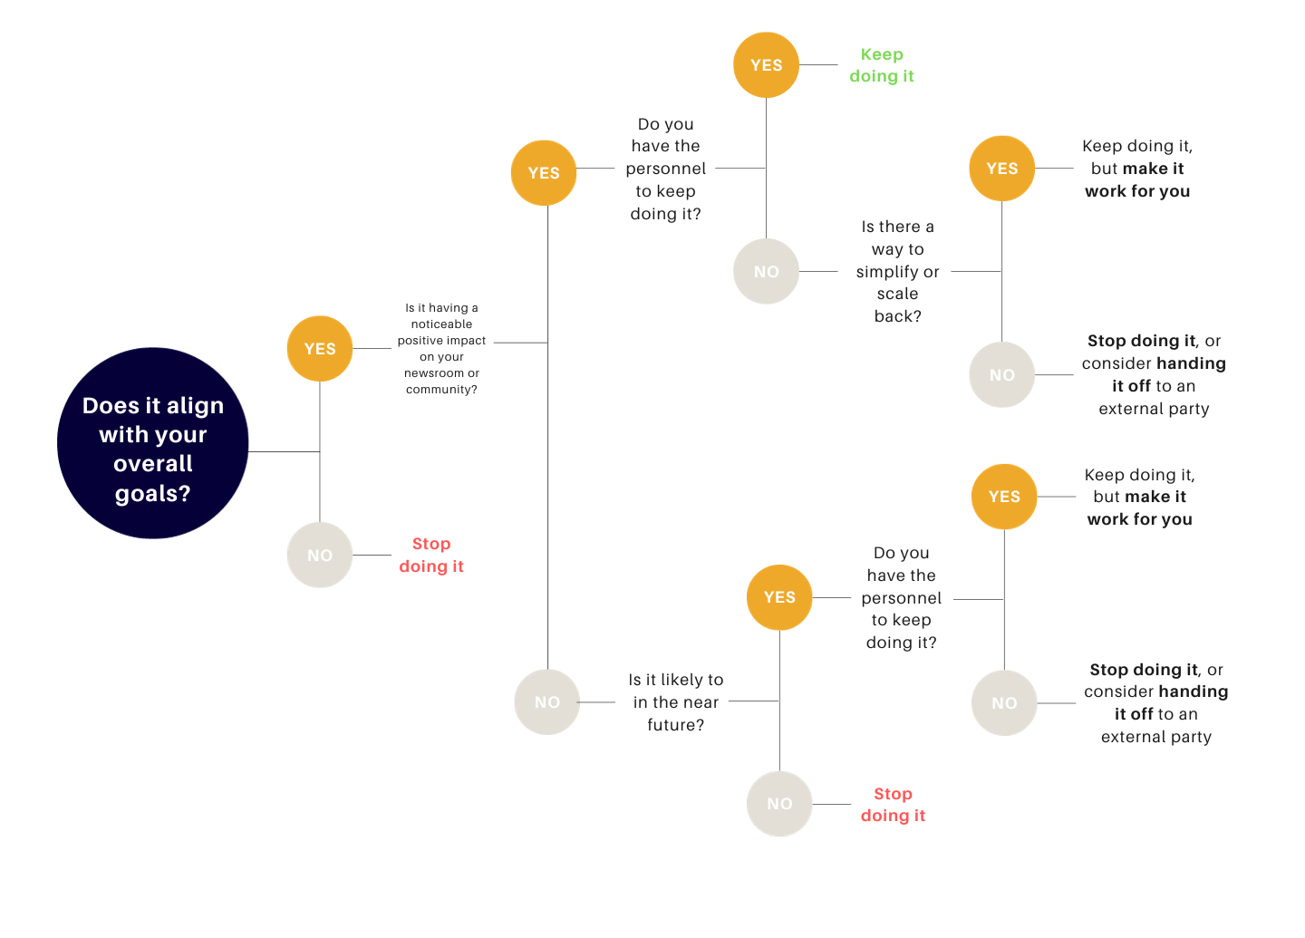

| **Start**  *What do we want to start doing?* | **Stop**  *What do we need to stop doing?* | **Continue**  *What do we need to continue doing?* |
| --- | --- | --- |
|  |  |  |

Action Plan

How can I **stop doing** the things that I’ve identified?

| 1.  2.  3. |
| --- |

Action Plan

How can I **start doing** the things that I’ve identified?

| 1.  2.  3. |
| --- |